MARKING KEY
AGRICULTURE FORM 4
2025 END OF TERM 1 MZIMBA NORTH DISTRICT EXAMINATIONS
SECTION A (70 Marks)
Answer all questions in this section on the spaces provided
1. a. Name any two factors that affect nutrient status of the soil
- Soil pH Method of cultivation
- Parent material Crop removal
- Leaching of basic nutrients Nutrient uptake by plants
- Soil erosion (2 marks for any two)
b. Describe two factors that influence soil temperature
- Soil color-Black soils have higher temperatures because they absorb more heat
- Moisture content-Moist soil is cooler than a dry soil
- Vegetative cover- A covered soil has low temperatures because it receives less heat
- Soil depth- Top soil has more soil temperature variations than sub soil
(4 marks for any two)
c. Explain one effect of organic matters on sand soil
- Organic matters reduce leaching because they have a cementing effect
- Acidity is reduced due to reduced leaching of hydroxyl ions
(2 marks for any one)
2. a. Mention any types of farm machinery
- Human- Powered Implements
- Ox- drawn Implements
- Tractor- Drawn Implements
(2 marks for any two)
b. State one function of each of the following farm implements
i. Garden sprayer –
- Spraying pesticides
- Spraying herbicides
- Spraying foliar fertilizer to crops (1 mark for any one)
ii.Sub-soiler
- to cultivate compacted soil
- to break up the hard pan within the sub-soil
(1 mark for any one)
c. Explain any one way in which the following improved technologies help to increase food security
i. Mobile technology
- Use of phones help farmers to acquire new and better methods of production
ii. Use of fertilizers
- Use of fertilizers increase fertility of the soil thereby increasing farm yield
(4 marks)
3. Table 1 shoes information extracted on a farm. Use it to answer questions that follow.
i. Prepare a profit and loss account
SALES AND RECEIPTS | AMOUNT (MK) | PURCHASES AND EXPENCES | AMOUNT (MK)
Milk sales | 45,000.00 | Opening valuation | 15,000.00
Closing valuation | 40,000.00 | Cost of veterinary services | 2,000.00
 |  | Cost of feed | 8,000.00
 |  | Depreciation | 5,000.00
Total Income | 85,000.00 | Total expenditure | 30,000.00
 |  | Profit | 55,000.00
(4 marks), 1 mark for correct columns, 1 mark for correct entries, 1 mark for total income and expenditure, 1 mark for profit
ii. Explain any one way in which the inclusion of opening valuation is important in financial records
- It provides a starting point for accounting and financial reporting
- Presents initial value of assets, liabilities and equity at the beginning of an accounting period (2 marks for any one)
4. a.(i) State any two ways in which soil pH could be decreased
- Application of acid forming fertilizers
- Poor farming practices that cause soil erosion
- Leaching of basic nutrients
- receiving acidic rains
- nutrient uptake by plants (2 marks for any two)

(ii) Accumulation of soluble salts in the soil (1 mark)
b. Figure 2 is a diagram showing a type of soil structure. Use it to answer questions (i) and (ii)

(i) Name the type of soil structure
- Plate – like structure/platy structure
(1 mark)
ii. Give any two ways in which the type of soil structure mentioned in (i) is not ideal for crop production
- Has poor water holding capacity
- Does not support microbial activities
- Has poor drainage
- Has limited root penetration ( 2 marks)
c. . Describe any two ways in which the use of heavy machinery would destroy soil structure
- Compacts soil particles which reduces soil porosity
- Compaction of soil particles interferes with movement of water in the soil
(2 marks)
5. Use table 3 to answer questions that follow
Plot | Year 1 | Year 2 | Year 3 | Year 4
1 | Cotton | g/nuts | Maize | Cassava
2 | g/nuts | Maize | Cassava | Cotton
3 | Maize | Cassava | Cotton | g/nuts
4 | Cassava | Cotton | g/nuts | Maize
a. Name the cropping system
- Crop rotation
(1 mark)
b. State any two factors that were followed when designing the cropping system
- Alternating non leguminous crops with leguminous crops e.g. Maize and g/nuts
- Alternating deep rooted crops with shallow rooted. e.g. Cotton and g/nuts
- Alternating heavy feeders with light feeders
- crops that get attacked by the same pests, diseases and weeds should not follow each other
(2 marks for any two)
c. State two advantages of mixed cropping
- Saves land since the same piece of land is used for more than one crop
- Saves labor since some operations are done once and for all crops
- Enables the crops to benefit from each other. E.g. maize and groundnuts
- Reduce the risk of total crop failure since the farmer can depend on another crop
- Reduces the spread of pests and diseases since one crop that is resistant acts as a barrier
- controls soil erosion since many crops provide soil cover
(2marks for any two)

6. a State any two uses of a partial budget
- Is helpful when one wants to expand the existing enterprise
- Is helpful when one wants to change one enterprise for another
- Is helpful when one wants to buy a new farm machinery or equipment
- Is helpful when one wants to adopt a change in production technique
- When a farmer wants to introduce a new enterprise without changing another
(2 marks for any two)
b. Explain one way in which agricultural cooperatives enhance food security
- members have strong bargaining power for better prices and selling conditions hence high profit for buying food items
- members easily secure loan for buying agricultural inputs for high food production
- members adopt technology quickly by sharing knowledge for food production
- members buy inputs in bulks at a reduced price hence able to produce more food
(2 marks for any one)
7. a. Draw a mushroom and label the following parts
i gills
ii. Volva
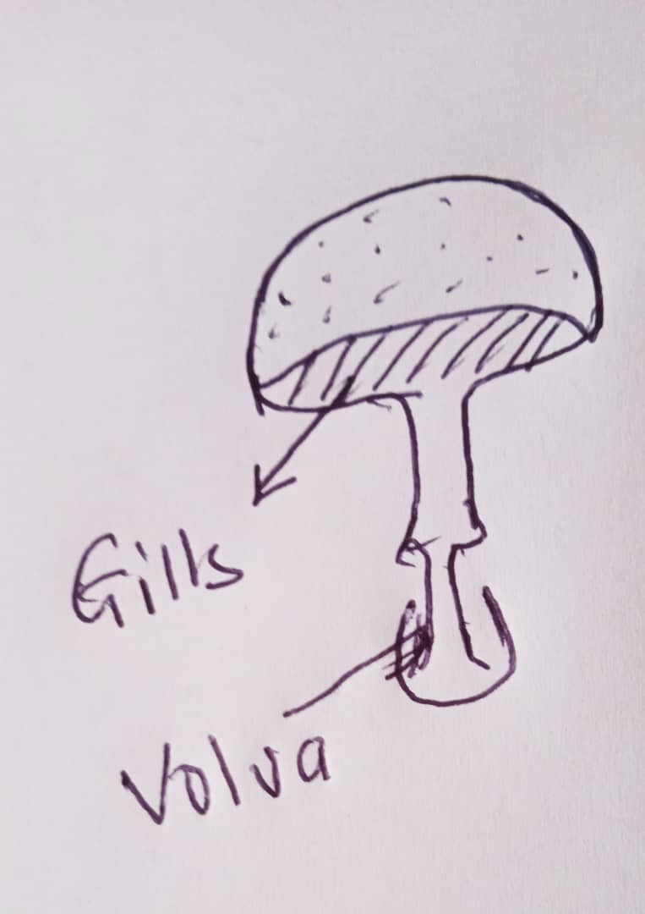
(3 marks)
b. Describe the two feeding habits of goats
- Grazing - Goats feed on pasture grass or herbs near ground level
- Browsing- Goats feed on any part of the plant such as leaves, barks, green stem and even root (4marks)
c. To provide them with required nutrients for growth and good health
- For production of more quality meat, milk and eggs
- For reproduction and enabling female animals to give birth to healthy and strong young ones
- To provide energy to draught animals (2 marks for an two)
8. a. Give two ways of improving output from human power.
- Motivating so that they can work harder
- Proper feeding
- Proper medication
- Providing training
- Providing suitable working conditions
- provide enough working materials
- assign tasks according to expertise (2 marks for any two)
b. State any two causes of chemical degradation
- Poor drainage
- Bushfires
- Industrial wastes
- Excessive irrigation
- Excessive use of chemicals (2 marks for any two)

C. Explain two biological measures of conserving soil
- Planting vegetation whose roots bind soil particles protecting it from being washed by running water
- Use of close growing crops to protect the soil from splash erosion
- Use of soil cover crops which protect the soil from splash erosion
- Planting trees which will help to protect the soil from wind erosion
- Application of manure which help to bind loose particles together
(4marks for any two)
9. a. Give two advantages of subsurface drainage over surface drainage
- Does not interfere with useful land as compared to surface drainage
- Is not prone to gully erosion as compared to surface drainage
- Does not interfere with farm mechanization as compared to surface drainage (2marks)
b. State any two evidence of gender biases in agricultural technology
- Women lacking capital
- Food insecurity and starvation
- Women owning and using small pieces of land
- Women carrying farm operations using unimproved farming technologies
- Women failing to access new technology
- Slow industrial development
(2marks for any two)
c. Give any two ways of dealing with gender biases in agricultural technology
- put more women in decision-making positions
- review land and property ownership laws
- improve access to education for both boys and girls
- discrediting gender stereotyping
- develop documentaries of successful women farmers
- promote equal skill development for both males and females
(2 marks for any two)

10.a. A farmer observed the following signs of a disease attack in sheep
- swollen feet
- difficulty in walking
- Name the disease the sheep were suffering from
- foot rot
(1 marks)
- Mention the cause of the disease
- bacteria
(1 mark)

- State any two ways of controlling the disease
- avoid grazing animals in muddy/marshy/damp areas
- provide animals with foot bath of formalin or copper sulphate solution
- isolate the animals
- treat the wounds with antibiotics eg tetracycline (2 marks for any two)

Section B (30 marks)
Answer all the three questions in this section. Your answers should be in an essay form.
11. Explain any five factors to consider when mechanizing a farm
- Accessibility of the land/ should be accessible to machine such as tractor
- Availability of capital/requires enough capital to buy machinery and spare parts
- Value of the crop/ should be of high value in order to cover the costs of mechanization
- Infrastructures/ requires enough structures e.g. roads, market, sheds etc.
- Technical know-how/requires skills to operate, maintain and repair
- size of land holding/ requires large land for easy movement of machines
(10 marks for any five)
12. Explain any five factors that affect soil PH
- Use of acid forming fertilizers /cause chemical reactions to take place in the soil increasing hydrogen ions
- Leaching/washing down of soluble cations leave hydrogen ions which increases acidity
- Parent material/soils formed from rocks which contain sulphur have low pH
- Soil erosion/ soil nutrients are washed hydrogen ions remain which increases acidity
- Nutrient uptake by plants/plant nutrients which were absorbed by plants become lost during harvesting especially when residues are removed and burnt leaving hydrogen ions which increases acidity
- Acid rains/rain water combines with carbon compounds to form carbonic acid
- Microbial activities/microorganisms release carbon dioxide during respiration which combines with water to form carbonic acid
(10 marks for any five)
13. Farmers in a certain village have the following resources at their disposal
- Agricultural research Station
- Fish pond
- Domesticated birds
- Arable land
Explain any five ways farmers in this community would use the resources to mitigate climate change
- Farmers will get advice on what crops they can grow to match with climate change from agricultural research stations
- Farmers will use water drained from the pond to irrigate crops when rains are insufficient
- Droppings collected from birds can be used to fertilize planktons in the pond which is feed for fish
- Farmers can sell fish and use the realized money to buy farm inputs thereby increasing quality and quantity of the crops
- Droppings collected from domesticated birds can be used as a source of fertilizer increasing soil nutrients in gardens
- Fish meal made from fish can be used as feed for the domesticated birds increasing production
(10 marks for any five)

